**Model Development Phase Template**

|  |  |
| --- | --- |
| Date | 1 JUNE 2025 |
| Team ID | xxxxxx |
| Project Title | CRIME VISION: ADVANCED CRIME CLASSIFICATION LEARNING |
| Maximum Marks | 10 Marks |

**Initial Model Training Code, Model Validation and Evaluation Report**

The initial model training code will be showcased in the future through a screenshot. The model validation and evaluation report will include a summary and training and validation performance metrics for multiple models, presented through respective screenshots.

**Initial Model Training Code (5 marks):**

Paste the screenshot of the model training code

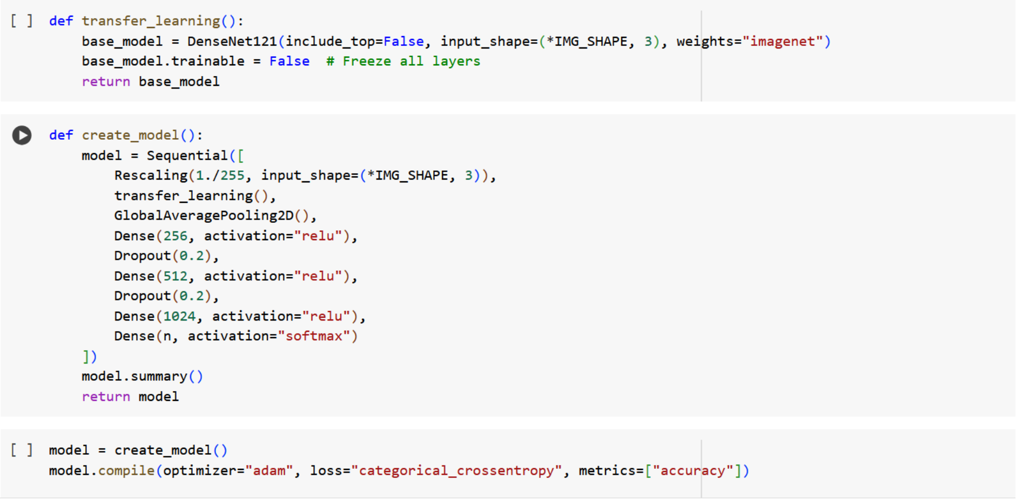

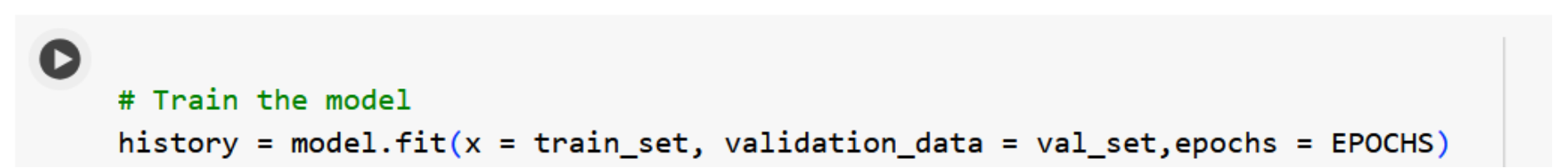

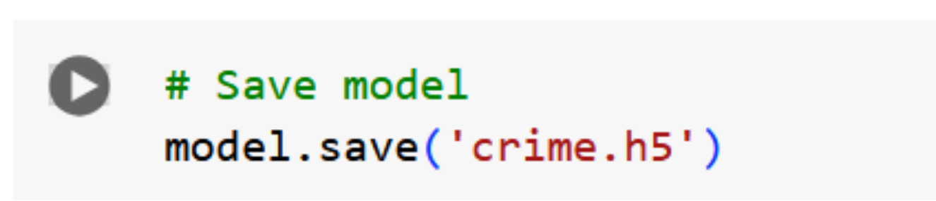

**Model Validation and Evaluation Report (5 marks):**

|  |  |  |
| --- | --- | --- |
| **Model** | **Summary** | **Training and Validation Performance Metrics** |
| Model 1 |  |  |